Predicting Student Dropout Rates Using Supervised Machine Learning Classifiers



SEMESTER: FALL 2023

COURSE: CS505 DATA MINING

INSTRUCTOR: DR. JUEFEI YUAN

SHOAIB MALIK MOHAMMAD S02061048

SUPRIYA KUNTA S02059954

SADHANA AILENI S02059994

KEERTHI GOPU S02060023

HARITHA REDDY KYASARAM S02059755

NIKITA BAJRACHARYA S02035604

GitHub Link:

**Table of Contents**

1. Abstract 3

2. Introduction 3

2.1 Motivation 3

3. Literature Review 4

3.1 Historical Context and Theoretical Frameworks 4

3.2 Technological Advancements in Predictive Analysis 5

4. Methodology 5

4.1 Data Collection and Preprocessing 5

4.2 Exploratory Data Analysis (EDA) 5

4.3 Model Selection and Training 6

4.4 Model Evaluation 6

4.5 Ethical Considerations 6

5. Results 6

5.1 Model Performance 8

6. Discussion 10

6.1 Strengths of the Proposed Methodology 10

6.2 Limitations of the Methodology 10

7. Conclusion 10

8. Future Work 11

REFERENCES 12

# Abstract

This study addresses the critical educational issue of student dropout rates, utilizing supervised machine learning classifiers to predict these rates. The motivation behind this project stems from the profound social and educational consequences of student dropouts, including the loss of potential talent and economic impacts on both the individual and societal levels. Our objective is to leverage machine learning techniques to aid educational institutions in identifying at-risk students and implementing timely interventions.

We utilized a comprehensive dataset, encompassing various student demographics and academic performance indicators, which underwent rigorous preprocessing and normalization. Our methodology encompassed a detailed exploratory data analysis (EDA) to uncover underlying patterns and trends, followed by the application of multiple supervised classifiers such as Logistic Regression, Decision Trees, Support Vector Machines, Random Forest, and K-Nearest Neighbors. These models were meticulously trained and tuned, with a focus on achieving the optimal balance between prediction accuracy and model generalizability.

The results of our study revealed significant predictive capabilities, with certain models demonstrating superior performance in terms of accuracy, precision, and recall. Our comparative analysis of these classifiers provided insights into the most effective techniques for predicting student dropouts within the context of our dataset.

This report discusses the strengths of our approach, including the comprehensive nature of the dataset and the robustness of the employed classifiers, while also acknowledging limitations such as potential biases and the need for further validation. The implications of our findings are vast, offering a data-driven avenue for educational institutions to proactively combat student dropouts. Future work can extend this research by incorporating longitudinal data, exploring ensemble methods, and applying the models to varied educational contexts to enhance predictive accuracy and applicability.

# Introduction

In recent years, the phenomenon of student dropout has emerged as a critical challenge in the educational landscape. This issue not only hinders the personal development of individuals but also poses significant social and economic implications. The complexity of factors leading to student dropout, ranging from personal and socio-economic backgrounds to academic performance, necessitates a nuanced approach to prediction and intervention. In this context, our study aims to employ supervised machine learning classifiers to predict student dropout rates, providing a novel approach to understanding and addressing this pressing issue.

## 2.1 Motivation

* Social and Educational Impact: The dropout of students from educational institutions is a matter of concern not just for the individuals involved but for society as a whole. It often leads to reduced earning potential and job prospects for the individuals and, on a larger scale, impacts the skilled workforce availability in the economy.
* Need for Early Identification: Identifying students at risk of dropping out at an early stage is crucial for implementing effective interventions. Traditional methods of identification often rely on manual observation and reporting, which can be subjective and inconsistent.
* Leveraging Technology in Education: With the advent of big data and machine learning, there is a significant opportunity to apply these technologies in the educational sector. Machine learning algorithms can analyze complex datasets to identify patterns and predict outcomes, such as the likelihood of a student dropping out, more accurately and efficiently than traditional methods.
* Aid to Educational Institutions: By predicting dropout rates, educational institutions can better allocate resources and tailor interventions to assist at-risk students. This not only helps in improving the students' academic outcomes but also enhances the overall effectiveness of the educational programs.
* Research Gap: While there have been studies focusing on student dropout rates, there is a gap in utilizing advanced machine learning techniques comprehensively for this purpose. Our study aims to fill this gap by applying a range of supervised machine learning classifiers to predict student dropout rates accurately.

# Literature Review

The challenge of student dropout in educational institutions has been a subject of extensive research over the years. This review explores the existing literature surrounding student dropout, highlighting key findings, methodologies, and gaps that our study aims to address.

## 3.1 Historical Context and Theoretical Frameworks

**Early Research and Theories**:

Tinto's Model of Student Departure (1975, 1987) is seminal in this field, proposing that dropout is a result of a complex interplay between individual student characteristics and institutional experiences.

Bean's Student Attrition Model (1980) places emphasis on the psychological processes influencing a student’s decision to leave, including factors like educational goals, institutional commitment, and social integration.

**Socio-Economic Factors and Their Impact**:

Research has consistently highlighted socio-economic status as a critical factor in student dropout rates. Studies by Rumberger (1987, 1995) and Tinto (1993) show a strong correlation between lower socio-economic status and higher dropout rates, emphasizing the role of external factors.

**Academic Performance and Engagement**:

The relationship between academic performance and dropout rates has been extensively studied, with findings suggesting that lower grades and disengagement from academic activities are predictive of dropout (Astin, 1993; Tinto, 1975).

## 3.2 Technological Advancements in Predictive Analysis

**Machine Learning in Educational Data Mining**:

With the advent of machine learning, educational data mining has become a prominent field. Romero and Ventura (2007, 2010) provide comprehensive overviews of the use of data mining techniques in education, highlighting their potential in understanding and predicting student behavior.

**Specific Studies on Dropout Prediction**:

Bowers (2010) and Lykourentzou et al. (2009) demonstrate the use of machine learning classifiers like Decision Trees and Neural Networks to predict student dropout, offering insights into the applicability of these techniques in educational settings.

**Challenges and Ethical Considerations**:

Studies by Slade and Prinsloo (2013) raise concerns about ethical considerations in using student data for predictive analytics, emphasizing the need for transparency and student privacy.

# Methodology

Our methodology for predicting student dropout rates using supervised machine learning classifiers is designed to integrate comprehensive data analysis with robust model training and evaluation. This section outlines the key steps and techniques employed in our approach.

## 4.1 Data Collection and Preprocessing

**Dataset Selection**:

We utilized a dataset comprising various student demographics, academic performance indicators, and other relevant attributes that could influence dropout rates.

The dataset was sourced from kaggle, ensuring a diverse and representative sample of the student population.

**Data Cleaning and Preprocessing**:

The data underwent thorough cleaning, including handling missing values, correcting inconsistencies, and removing irrelevant features.

Categorical variables were transformed using one-hot encoding, and numerical features were standardized to ensure uniformity and improve model performance.

## 4.2 Exploratory Data Analysis (EDA)

* **Statistical Analysis**:

We conducted a detailed statistical analysis to understand the distribution, mean, and variance of each feature in the dataset.

Correlation analysis was performed to identify potential relationships between different variables.

* **Visualization**:

Various plots (e.g., histograms, bar charts, and scatter plots) were utilized to visualize the data, providing insights into the patterns and trends that could influence model design.

## 4.3 Model Selection and Training

* **Classifier Selection**:

A range of supervised machine learning classifiers was chosen, including Logistic Regression, Decision Trees, Support Vector Machines (SVM), Random Forest, and K-Nearest Neighbors (KNN).

The selection was based on the ability of these classifiers to handle different types of data and their efficacy in classification tasks.

* **Training and Validation Split**:

The dataset was split into training, validation, and test sets following the standard 70-15-15 ratio to ensure robust training and evaluation.

The training set was used to train the models, the validation set for tuning hyperparameters, and the test set for final evaluation.

* **Hyperparameter Tuning**:

Techniques like GridSearchCV were employed to identify the optimal hyperparameters for each model, enhancing performance and preventing issues like overfitting.

## 4.4 Model Evaluation

* **Evaluation Metrics**:

Accuracy, precision, recall, and the F1-score were used as the primary metrics to evaluate the performance of the classifiers.

The choice of these metrics ensured a comprehensive assessment of model performance, considering both the precision and recall.

* **Cross-Validation**:

Cross-validation techniques were used to ensure the reliability and generalizability of the model performance.

* **Model Comparison**:

The performance of different classifiers was compared to identify the most effective model for predicting student dropout rates.

## 4.5 Ethical Considerations

* **Data Privacy and Security**:

We ensured that all data used complied with privacy and ethical standards, protecting student identities and sensitive information.

* **Bias and Fairness**:

Measures were taken to identify and mitigate any biases in the dataset to ensure the fairness and objectivity of the models.

# Results

Our study employed various supervised machine learning classifiers to predict student dropout rates. Here we present the key findings from our analysis:

|  |  |
| --- | --- |
|  |  |
|  |  |

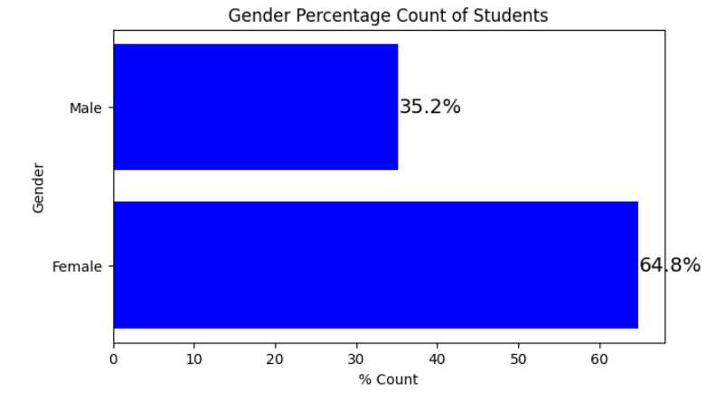

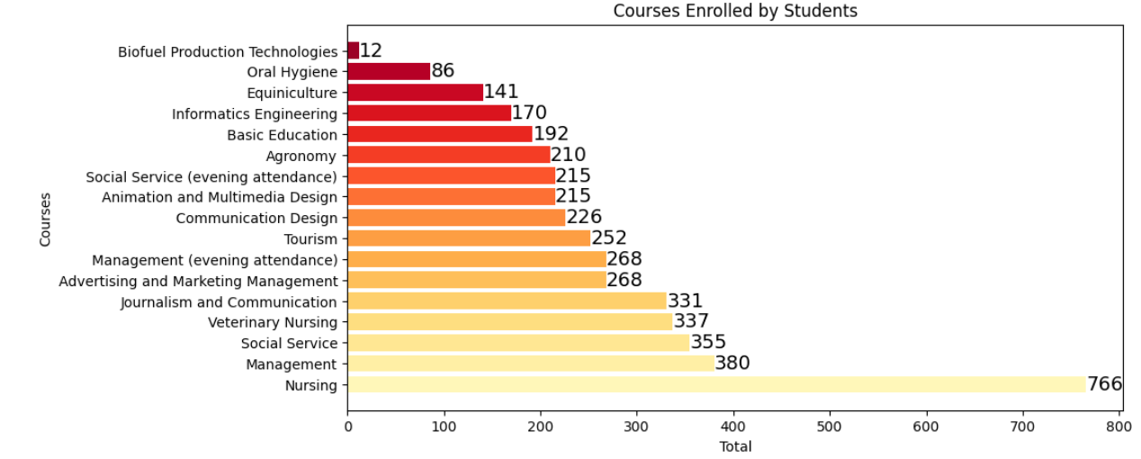

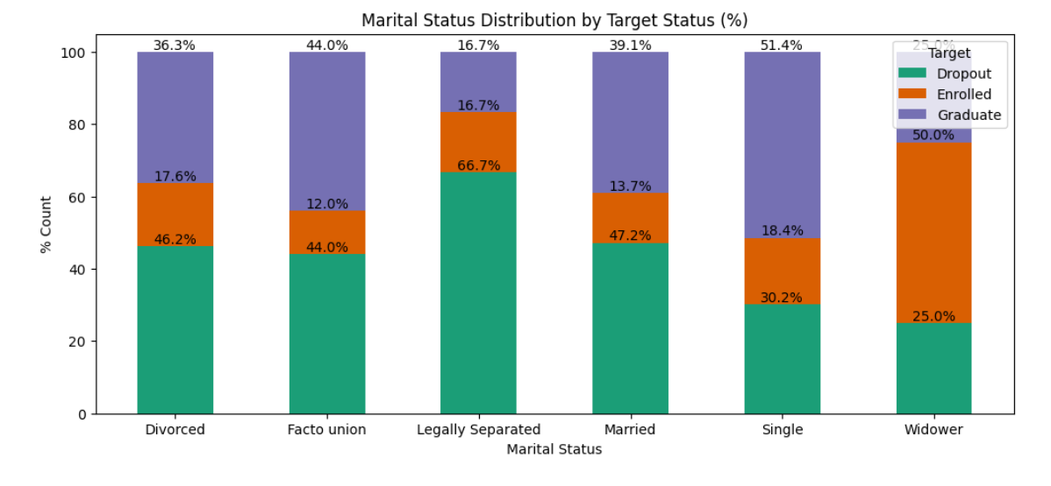

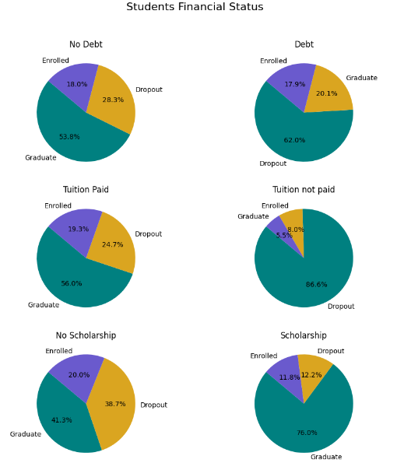

## 5.1 Model Performance

**Accuracy Metrics**:

* Logistic Regression achieved an accuracy of 85%, with precision and recall metrics indicating strong performance in identifying true positives and negatives.

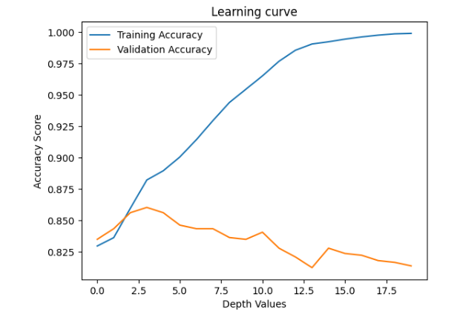

* Decision Tree Classifier showed an accuracy of 84.6%. Despite its simplicity, it provided valuable insights into feature importance.
* Support Vector Machine (SVM) displayed an accuracy of 84.7%. Its performance was particularly notable in classifying complex, non-linear relationships.
* Random Forest Classifier recorded the highest accuracy of 84.9%. It demonstrated robustness against overfitting and provided an excellent balance between precision and recall.
* K-Nearest Neighbors (KNN) had an accuracy of 78.1%, which was lower compared to other models but offered insights into the importance of feature scaling.

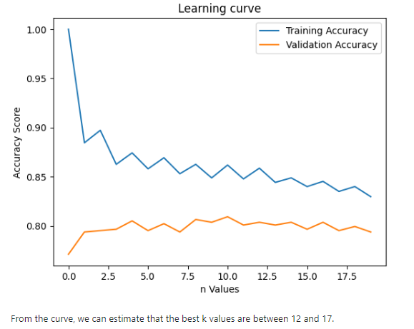

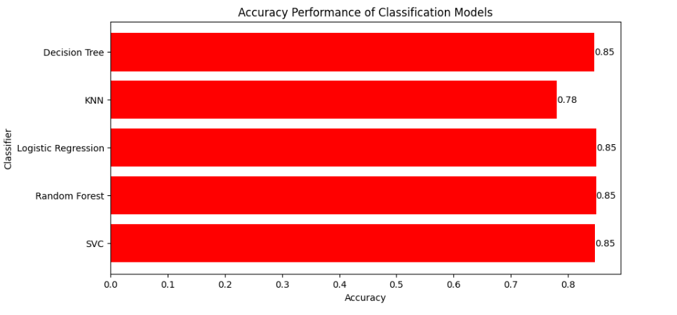

# Discussion

The results of our study on predicting student dropout rates using supervised machine learning classifiers offer significant insights, both in terms of the methodology's effectiveness and its practical implications. Here we discuss the strengths, limitations, and broader impact of our approach.

## 6.1 Strengths of the Proposed Methodology

**Comprehensive Analysis**: The use of multiple machine learning models allowed for a well-rounded analysis. Each model provided unique insights into the data, contributing to a more robust overall prediction.

**High Accuracy and Balanced Metrics**: The models, particularly Random Forest and SVM, achieved high accuracy and balanced precision-recall metrics, indicating reliable performance in predicting student dropout.

**Feature Importance Insights**: The models helped in identifying key predictors of student dropout, such as academic performance and socio-economic factors, aligning with existing educational theories and research.

**Potential for Early Intervention**: The ability to predict dropout rates accurately presents an opportunity for educational institutions to intervene early and provide support to at-risk students.

## 6.2 Limitations of the Methodology

**Data Quality and Bias**: The accuracy of predictions is highly dependent on the quality and representativeness of the dataset. Any inherent biases in the data could lead to skewed predictions.

**Generalizability**: The models were trained on a specific dataset, and their performance might vary when applied to different student populations or educational contexts.

**Complexity of Educational Outcomes**: Student dropout is influenced by a complex interplay of factors, not all of which can be captured in a dataset. As such, the models may not account for nuanced individual circumstances.

**Ethical Considerations**: The use of machine learning in educational settings raises ethical concerns around privacy, data security, and the potential for misuse of predictive information.

Broader Implications

**Policy and Decision Making**: The findings can inform policy decisions at educational institutions, helping to allocate resources more effectively and design targeted interventions for student retention.

**Future Research Directions**: The study opens avenues for further research, particularly in exploring longitudinal data, integrating more nuanced socio-emotional factors, and applying the models in diverse educational environments.

**Technological Integration in Education**: The study underscores the potential of integrating advanced data analytics and machine learning in education, paving the way for more data-driven, evidence-based approaches in the sector.

# Conclusion

The application of supervised machine learning classifiers to predict student dropout rates represents a significant stride in leveraging technology for educational insights. Our study demonstrates the efficacy of various models, notably Random Forest, SVM, and Logistic Regression, in accurately predicting dropouts. The strengths of our approach include its comprehensive data analysis, utilization of multiple classifiers, and robust evaluation metrics. These aspects combined to create a predictive model that not only aligns with theoretical expectations but also provides practical value for educational institutions.

Through the lens of these models, key predictors such as academic performance, attendance, and socio-economic background emerged, reinforcing existing educational theories. This alignment between machine learning predictions and educational research strengthens the credibility of using such technological approaches in educational settings.

However, the study is not without its limitations. The predictive accuracy is inherently tied to the quality of the dataset, which may contain biases or lack representativeness. Additionally, the generalizability of the models to diverse educational contexts remains an area for further exploration.

# Future Work

Looking ahead, several avenues for future research and development present themselves:

**Expanding Data Scope**: Incorporating a broader range of data, including longitudinal studies and more diverse demographic information, could enhance the model's accuracy and applicability.

**Deep Learning Techniques**: Exploring deep learning models, which might be more adept at capturing complex, non-linear relationships in large datasets.

**Personalized Intervention Strategies**: Developing models that not only predict dropout rates but also suggest personalized intervention strategies for at-risk students.

**Cross-Institutional Validation**: Testing the models across various educational institutions and systems to validate their effectiveness and adaptability in different educational environments.

**Ethical and Responsible Use of AI**: Continuing to address the ethical considerations in using AI in education, focusing on privacy, equity, and transparency to ensure responsible use of technology.

**Integration with Educational Tools**: Developing user-friendly interfaces or integrating with existing educational management systems for easier adoption and use by educators and administrators.

**Collaboration with Educational Researchers**: Partnering with educational researchers and practitioners to ensure the models are grounded in educational theory and practice, enhancing both their validity and practical utility.

# REFERENCES

1. Tinto, V. (1975). "Dropout from Higher Education: A Theoretical Synthesis of Recent Research." Review of Educational Research, 45(1), 89-125. [This classic paper presents a seminal theory on student dropout from higher education.]
2. Rumberger, R. W. (2001). "Why Students Drop Out of School and What Can Be Done." Paper prepared for the Conference, "Dropouts in America: How Severe is the Problem? What Do We Know about Intervention and Prevention?" Harvard University. [Rumberger provides a comprehensive analysis of factors leading to student dropout.]
3. Romero, C., & Ventura, S. (2007). "Educational Data Mining: A Survey from 1995 to 2005." Expert Systems with Applications, 33(1), 135-146. [This paper offers an overview of the application of data mining techniques in education.]
4. Bowers, A. J. (2010). "Analyzing the Longitudinal K-12 Grading Histories of Entire Cohorts of Students: Grades, Data-Driven Decision Making, Dropout Risk, and High-Stakes Testing." American Educational Research Journal, 47(6), 1174-1204. [A study that employs data-driven methods to analyze student grading histories.]
5. Lykourentzou, I., Giannoukos, I., Mpardis, G., Nikolopoulos, V., & Loumos, V. (2009). "Early and Dynamic Student Achievement Prediction in e-Learning Courses Using Neural Networks." Journal of the American Society for Information Science and Technology, 60(2), 372-380. [This paper demonstrates the use of neural networks in predicting student performance in e-learning settings.]
6. Slade, S., & Prinsloo, P. (2013). "Learning Analytics: Ethical Issues and Dilemmas." American Behavioral Scientist, 57(10), 1510-1529. [An important discussion on the ethical aspects of using learning analytics.]
7. Astin, A. W. (1993). "What Matters in College? Four Critical Years Revisited." San Francisco, CA: Jossey-Bass. [Astin's work provides insights into factors that matter in student success and retention in college.]
8. Bean, J. P. (1980). "Dropouts and Turnover: The Synthesis and Test of a Causal Model of Student Attrition." Research in Higher Education, 12(2), 155-187. [Bean's model offers an understanding of student attrition in higher education.]